Compiler Design Notes
COMPILER DESIGN
Introduction to compiler

A compiler is a program that can read a program in one language - the source
language and translate it into an equivalent program in another language - the target
language. An important role of the compiler is to report any errors in the source
program that it detects during the translation process.

If the target program is an executable machine-language program, it can then be
called by the user to process inputs and produce outputs.

INTERPRETER

An interpreter is another common kind of language processor. Instead of
producing a target program as a translation, an interpreter appears to directly execute
the operations specified in the source program on inputs supplied by the user.

Prepared By Dipendra Air

1
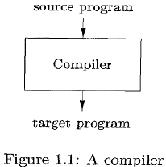

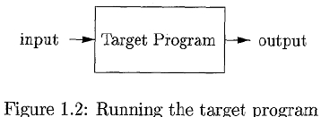

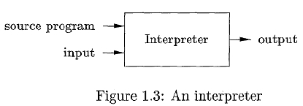

Compiler Design Notes
Comparison between Compiler & Interpreter:

The machine-language target program produced by a compiler is usually much
faster than an interpreter at mapping inputs to outputs. An interpreter, however, can
usually give better error diagnostics than a compiler, because it executes the source
program statement by statement.

HYBRID COMPILER

Java language processors combine compilation and interpretation, as shown in
Fig. 1.4. A Java source program may first be compiled into an intermediate form called
bytecodes. The bytecodes are then interpreted by a virtual machine. A benefit of this
arrangement is that bytecodes compiled on one machine can be interpreted on another
machine.

In addition to a compiler, several other programs may be required to create an
executable target program.

Preprocessor

A source program may be divided into modules stored in separate files. The task
of collecting the source program is sometimes entrusted to a separate program, called a
preprocessor. The preprocessor may also expand shorthands, called macros, into
source language statements.

Compiler

The modified source program is then fed to a compiler. The compiler may
produce an assembly language program as its output, because assembly language is
easier to produce as output and is easier to debug.

Prepared By Dipendra Air

2
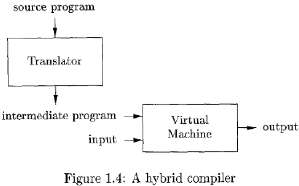

Compiler Design Notes
Assembler

The assembly language is then processed by a program called an assembler that
produces relocatable machine code as its output.

Large programs are often compiled in pieces, so the relocatable machine code
may have to be linked together with other relocatable object files and library files into
the code that actually runs on the machine.

Linker/ Loader

The linker resolves external memory addresses, where the code in one file may
refer to a location in another file.
The loader then puts together the entire executable object files into memory for
execution. In order to achieve faster processing of inputs to outputs, some Java
compilers, called just-in-time compilers, translate the bytecodes into machine language
immediately before they run the intermediate program to process the input.

A language-processing system:

Prepared By Dipendra Air

3
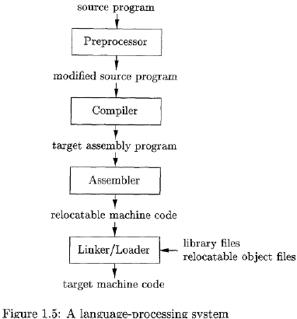

Compiler Design Notes
The Structure of a Compiler

Analysis of the Source Program:

A compiler is as a single box that maps a source program into a semantically
equivalent target program. There are two parts to this mapping: analysis and
synthesis.
The analysis part breaks up the source program into constituent pieces and
imposes a grammatical structure on them. It then uses this structure to create an
intermediate representation of the source program. If the analysis part detects that the
source program is either syntactically ill formed or semantically unsound, then it must
provide informative messages, so the user can take corrective action. The analysis part
also collects information about the source program and stores it in a data structure
called a symbol table, which is passed along with the intermediate representation to
the synthesis part.

The synthesis part constructs the desired target program from the intermediate
representation and the information in the symbol table. The analysis part is often called
the front end of the compiler; the synthesis part is the back end.

Prepared By Dipendra Air

4

Compiler Design Notes
Phases of a compiler

If we examine the compilation process in more detail, it operates as a sequence
of phases, each of which transforms one representation of the source program to
another.
A typical decomposition of a compiler into phases.

In practice, several phases may be grouped together, and the intermediate
representations between the grouped phases need not be constructed explicitly. The
symbol table, which stores information about the entire source program, is used by all
phases of the compiler.

Prepared By Dipendra Air

5
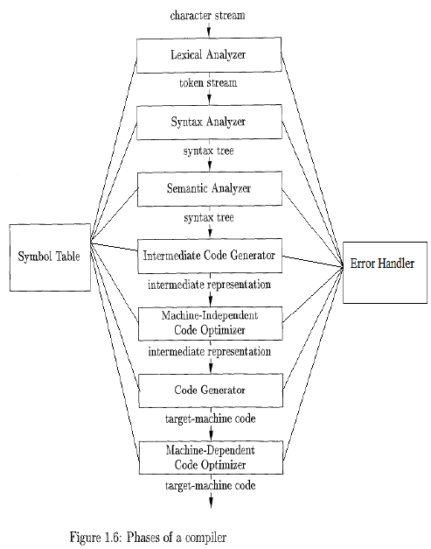

Compiler Design Notes
1. Lexical Analysis:

lexical analysis or scanning forms the first phase of a compiler. The lexical
analyzer reads the stream of characters which makes the source program and groups
them into meaningful sequences called lexemes. For each lexeme, the lexical analyzer
produces tokens as output. A token format is shown below.

<token-name, attribute-value>

These tokens pass on to the subsequent phase known as syntax analysis. The token
elements are listed below:

o Token-name: This is an abstract symbol used during syntax analysis.

o Attribute-value: This point to an entry in the symbol table for the
corresponding token.
Information from the symbol-table entry 'is needed for semantic analysis and code
generation.
For example, let us try to analyze a simple arithmetic expression evaluation in Lexical
context

position = initial + rate * 60

The individual units in the above expression can be grouped into lexemes.

a. position is a lexeme that would be mapped into a token <id, 1>, where id is an
abstract symbol standing for identifier and 1 points to the symbol table entry for
position. The symbol-table entry for an identifier holds information about the
identifier, such as its name and type.

b. The assignment symbol = is a lexeme that is mapped into the token <=>. Since this
token needs no attribute-value, we have omitted the second component. We could
have used any abstract symbol such as assign for the token-name, but for notational
convenience we have chosen to use the lexeme itself as the name of the abstract
symbol.

c. initial is a lexeme that is mapped into the token <id, 2>, where 2 points to the
symbol-table entry for initial.

d. + is a lexeme that is mapped into the token <+>.

e. rate is a lexeme that is mapped into the token <id, 3>, where 3 points to the
symbol-table entry for rate.

Prepared By Dipendra Air
6

Compiler Design Notes

f. * is a lexeme that is mapped into the token <*>.

g. 60 is a lexeme that is mapped into the token <60>. Blanks would be discarded by the

lexical analyzer.

The expression is seen by Lexical analyzer as

<id,1> <=> <id,2> <+> <id,3> <*> <60>

The token names =, +, and * are abstract symbols for the assignment, addition, and

multiplication operators, respectively.

Prepared By Dipendra Air

7

Compiler Design Notes

Prepared By Dipendra Air

8
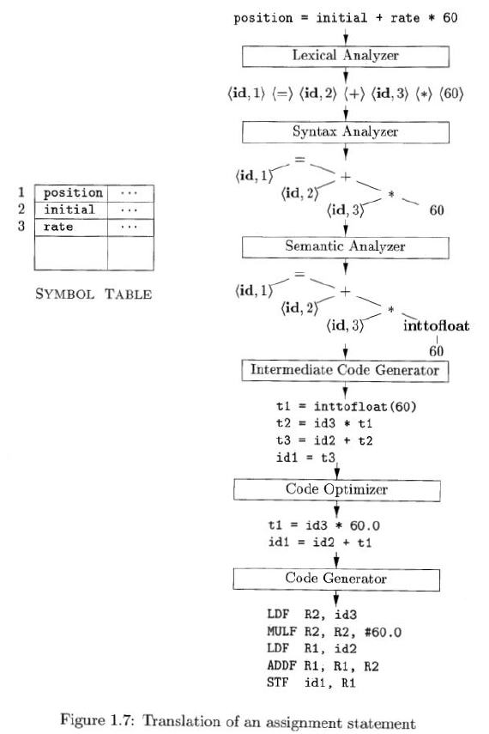

Compiler Design Notes
2. Syntax Analysis:

Syntax analysis forms the second phase of the compiler.
The list of tokens produced by the lexical analysis phase forms the input and arranges
them in the form of tree-structure (called the syntax tree).This reflects the structure
of the program. This phase is also called parsing.
The syntax tree consists of interior node representing an operation and the child of
the node representing arguments. A syntax tree for the token statement is as shown in
the above example.
Operators are considered as root nodes of this syntax tree. In the above case = has
left and a right node. The left node consists of <id,1> and the right node Is again
parsed and the immediate operator is taken as right node.

Figure 1.4 Syntax Tree

The tree has an interior node labeled * with <id, 3> as its left child and the integer
60 as its right child. The node <id, 3> represents the identifier rate.
The node labeled * makes it explicit that we must first multiply the value of rate by
60. The node labeled + indicates that we must add the result of this multiplication to
the value of initial.
The root of the tree, labeled =, indicates that we must store the result of this addition
into the location for the identifier position.
This ordering of operations is consistent with the usual conventions of arithmetic
which tell us that multiplication has higher precedence than addition, and hence that
the multiplication is to be performed before the addition.

3. Semantic analysis:

Semantic analysis forms the third phase of the compiler. This phase uses the syntax
tree and the information in the symbol table to check the source program for
consistency with the language definition. This phase also collects type information and
saves it in either the syntax tree or the symbol table, for subsequent use during
intermediate-code generation.

Type checking forms an important part of semantic analysis. Here the compiler
checks whether each operator has matching operands. For example, many programming

Prepared By Dipendra Air
9
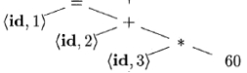

Compiler Design Notes
language definitions require an array index to be an integer; the compiler must report
an error if a floating- point number is used to index an array.

Coercions(some type conversions) may be permitted by the language specifications.

If the
operator is applied to a floating-point number and an integer, the compiler may

convert or coerce the integer into a floating-point number.

Coercion exists in the example quoted

position = initial + rate * 60

Suppose position, initial and rate variables are declared as float. Since the <id, 3> is a
floating point, then 60 is also converted to floating point. The semantic tree (Fig 1.5) can be
seen as follows. The syntax tree is modified to include the conversion/semantic aspects. In
the example quoted 60 is converted to float as inttofloat

Figure 1.5 Semantic Tree

4. Intermediate Code Generation:

Intermediate code generation forms the fourth phase of the compiler. After
syntax and semantic analysis of the source program, many compilers generate a low-
level or machine-like intermediate representation, which can be thought as a program
for an abstract machine.
This intermediate representation must have two important properties:

(a) It should be easy to produce

(b) It should be easy to translate into the target machine.

The above example is converted into three-address code sequence
There are several points worth noting about three-address instructions.

1. First each three-address assignment instruction has at most one operator on the
right side. Thus, these instructions fix the order in which operations are to be done;
the multiplication precedes the addition in the source program (1.1).
2. Second, the compiler must generate a temporary name to hold the value computed

Prepared By Dipendra Air
10
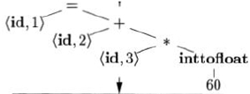

Compiler Design Notes
by a three-address instruction.
3. Third, some "three-address instructions" like the first and last in the sequence have
fewer than three operands.

t1 = inttofloat (60)

t2 = id3 * t1

t3 = id2 + t2
id1 = t3

5. Code Optimization:

Code Optimization forms the fifth phase in the compiler design.
This is a machine-independent phase which attempts to improve the intermediate
code for generating better (faster) target code.
For example, a straightforward algorithm generates the intermediate code (1.3),
using an instruction for each operator in the tree representation that comes from the
semantic analyzer.
The optimizer can deduce that the conversion of 60 from integer to floating point can
be done once and for all at compile time, so the intto-float operation can be
eliminated by replacing the integer 60 by the floating-point number 60.0.

Moreover, t3 is used only once to transmit its value to

id1
so the optimizer can

transform the above three-address code sequence into a shorter sequence.

t1= id3 * 60.0

id1 = id2 + t1

6. Code Generator:

Code Generator forms the sixth phase in the compiler design. This takes the
i ntermediate representation of the source program as input and maps it to the target
language.
The intermediate instructions are translated into sequences of machine instructions
that perform the same task. A critical aspect of code generation is the assignment of
registers to hold variables.
Using R1 & R2 the intermediate code will get converted into machine code.

LDF R2, id3

Prepared By Dipendra Air

11

Compiler Design Notes
MULF R2, R2, #60.0
LDF R1, id2
ADDF R1, R1, R2
STF id1, R1
The first operand of each instruction specifies a destination. The F in each
instruction tells us that it deals with floating-point numbers. The code in loads the
contents of address id3 into register R2, then multi- plies it with floating-point
constant 60.0.
The # signifies that 60.0 is to be treated as an immediate constant. The third
instruction moves id2 into register R1 and the fourth adds to it the value
previously computed in register R2. Finally, the value in register R1 is stored into the
address of id1, so the code correctly implements the assignment statement.

Symbol-Table Management

An essential function of a compiler is to record the variable names used in the
source program and collect information about various attributes of each name.
These attributes may provide information about the storage allocated for a name,
its type, its scope (where in the program its value may be used), and in the case of
procedure names, such things as the number and types of its arguments, the
method of passing each argument (for example, by value or by reference), and the
type returned.
The symbol table is a data structure containing a record for each variable name,
with fields for the attributes of the name.

The Grouping of Phases into Passes

Activities from several phases may be grouped together into a pass that reads an
input file and writes an output file.
For example, the front-end phases of lexical analysis, syntax analysis, semantic
analysis, and intermediate code generation might be grouped together into one
pass.
Code optimization might be an optional pass.
back-end pass consisting of code generation for a particular target machine.
Some compiler collections have been created around carefully designed
intermediate representations that allow the front end for a particular language to
interface with the back end for a certain target machine.

Prepared By Dipendra Air
12

Compiler Design Notes
With these collections, we can produce compilers for different source languages for
one target machine by combining different front ends with the back end for that
target machine.
Similarly, we can produce compilers for different target machines, by combining a
front end with back ends for different target machines.

Compiler-Construction Tools

Some commonly used compiler-construction tools include

1. Parser generators that automatically produce syntax analyzers from a grammatical
description of a programming language.
2. Scanner generators that produce lexical analyzers from a regular-expression
description of the tokens of a language.
3. Syntax-directed translation engines that produce collections of routines for
walking a parse tree and generating intermediate code.
4. Code-generator generators that produce a code generator from a collection of
rules for translating each operation of the intermediate language into the machine
language for a target machine.
5. Data-flow analysis engines that facilitate the gathering of information about how
values are transmitted from one part of a program to each other part. Data-flow
analysis is a key part of code optimization.
6. Compiler-construction toolkits that provide an integrated set of routines for
constructing various phases of a compiler

Prepared By Dipendra Air

13

Compiler Design Notes
The Role of Lexical Analyzer:

As the first phase of a compiler, the main task of the lexical analyzer is to read
the input characters of the source program, group them into lexemes, and produce as
output a sequence of tokens for each lexeme in the source program.

The stream of tokens is sent to the parser for syntax analysis. It is common for the
lexical analyzer to interact with the symbol table as well.

When the lexical analyzer discovers a lexeme constituting an identifier, it needs
to enter that lexeme into the symbol table. In some cases, information regarding the
kind of identifier may be read from the symbol table by the lexical analyzer to assist it
in determining the proper token it must pass to the parser.

The interaction is implemented by having the parser call the lexical analyzer.
The call, suggested by the getNextToken command, causes the lexical analyzer to read
characters from its input until it can identify the next lexeme and produce for it the
next token, which it returns to the parser. Since the lexical analyzer is the part of the
compiler that reads the source text, it may perform certain other tasks besides
identification of lexemes.

One such task is stripping out comments and whitespace (blank, newline, tab,
and perhaps other characters that are used to separate tokens in the input). Text, it
may perform certain other tasks besides identification of lexemes. One such task is
stripping out comments and whitespace (blank, newline, tab, and perhaps other
characters that are used to separate tokens in the input). Another task is correlating

Prepared By Dipendra Air

14
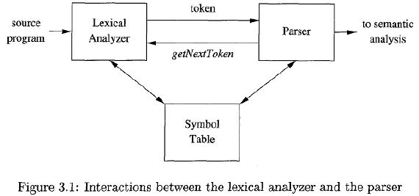

Compiler Design Notes
error messages generated by the compiler with the source program. The lexical
analyzer may keep track of the number of newline characters seen, so it can associate a
line number with each error message.

Sometimes, lexical analyzers are divided into a cascade of two processes:
a. Scanning consists of the simple processes that do not require tokenization of the
input, such as deletion of comments and compaction of consecutive whitespace
characters into one.
b. Lexical analysis proper is the more complex portion, where the scanner produces
the sequence of tokens as output.

Lexical Analysis versus Parsing

There are a number of reasons why the analysis portion of a compiler is
normally separated into lexical analysis and parsing (syntax analysis) phases.

1. Simplicity of design is the most important consideration.
2. Compiler efficiency is improved.
3. Compiler portability is enhanced.

Tokens, Patterns, and Lexemes

A token is a pair consisting of a token name and an optional attribute value.
The token name is an abstract symbol representing a kind of lexical unit, e.g., a
particular keyword, or a sequence of input characters denoting an identifier.

A pattern is a description of the form that the lexemes of a token may take. In
the case of a keyword as a token, the pattern is just the sequence of characters that form
the keyword. For identifiers and some other tokens, the pattern is a more complex
structure that is matched by many strings.

A lexeme is a sequence of characters in the source program that matches the
pattern for a token

Prepared By Dipendra Air

15

Compiler Design Notes

Figure 1.2 Examples of tokens

Attributes for Tokens

When more than one lexeme can match a pattern, the lexical analyzer must provide
the subsequent compiler phase’s additional information about the particular
lexeme that matched.
For example, the pattern for token number matches both 0 and 1, but it is extremely
important for the code generator to know which lexeme was found in the source
program.
Tokens have at most one associated attribute, although this attribute may have a
structure that combines several pieces of information. Information about an
identifier - e.g., its lexeme, its type, and the location at which it is first found (in case
an error message about that identifier must be issued) - is kept in the symbol table.

Example: The token names and associated attribute values for the Fortran statement

E = M * C ** 2

are written below as a sequence of pairs.

<id, pointer to symbol-table entry for E>
< assign-op >
<id, pointer to symbol-table entry for M>
<mult-op>
<id, pointer to symbol-table entry for C>
<exp-op>
<number, integer value 2 >
Note that in certain pairs, especially operators, punctuation, and keywords, there is
no need for an attribute value.
In this example, the token number has been given an integer-valued attribute.

Prepared By Dipendra Air

16
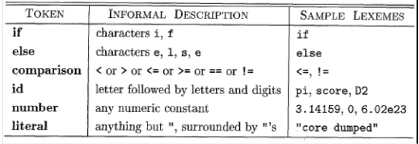

Compiler Design Notes
In practice, a typical compiler would instead store a character string representing
the constant and use as an attribute value for number a pointer to that string.

Lexical Errors

It is hard for a lexical analyzer to tell, without the aid of other components that
there is a source-code error.
fi(a = = f(x)) . . .
a lexical analyzer cannot tell whether fi is a misspelling of the keyword if or an
undeclared function identifier.
Since fi is a valid lexeme for the token id, here the lexical analyzer is unable to
proceed because none of the patterns for tokens matches any prefix of the
remaining input.
The simplest recovery strategy is "panic mode" recovery. Delete successive
characters from the remaining input, until the lexical analyzer can find a well-
formed token at the beginning of what input is left.

Other possible error-recovery actions are:
1. Delete one character from the remaining input.
2. Insert a missing character into the remaining input.
3. Replace a character by another character.
4. Transpose two adjacent characters.

Before discussing the problem of recognizing lexemes in the input, let us
examine
Some ways that the simple but important task of reading the source program can be
speeded. We then consider an improvement involving "sentinels" that saves time
checking for the ends of buffers.

Buffer Pairs

Because of the amount of time taken to process characters and the large number
of characters that must be processed during the compilation of a large source program,
specialized buffering techniques have been developed to reduce the amount of
overhead required to process a single input character.
An important scheme involves two buffers that are alternately reloaded, as
shown in the following as

Prepared By Dipendra Air
17

Compiler Design Notes

Each buffer is of the same size N, and N is usually the size of a disk block, e.g., 4096
bytes. If fewer than N characters remain in the input file, then a special character,
represented by eof, marks the end of the source file and is different from any possible
character of the source program.

Two pointers to the input are maintained:
1. Pointer lexemeBegin, marks the beginning of the current lexeme, whose extent we
are attempting to determine.
2. Pointer forward scans ahead until a pattern match is found;

Sentinels

For each character read, we make two tests:
- One for the end of the buffer,
- One to determine what character is read.
Here combine the buffer-end test with the test for the current character if we
extend each buffer to hold a sentinel character at the end.
The sentinel is a special character that cannot be part of the source program, and a
natural choice is the character eof.

Prepared By Dipendra Air

18
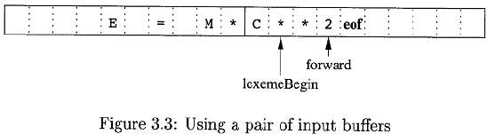

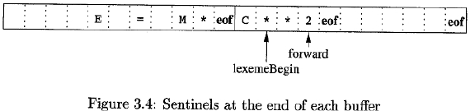

Compiler Design Notes
The algorithm for advancing forward:

switch ( *forward++ )
{
case eof:
if (forward is at end of first buffer )
{
reload second buffer;
forward = beginning of second buffer;
}
else if (forward is at end of second buffer )
{
reload first buffer;
forward = beginning of first buffer;
}
else /* eof within a buffer marks the end of input */
terminate lexical analysis;
break;
cases for the other characters
}
Figure 3.5: Lookahead code with sentinels

Specification of Tokens

Regular expressions are an important notation for specifying lexeme patterns.
While they cannot express all possible patterns, they are very effective in specifying
those types of patterns that we actually need for tokens.

Strings and Languages

An alphabet is any finite set of symbols. The set {0,1) is the binary alphabet
A string over an alphabet is a finite sequence of symbols drawn from that alphabet.
The empty string, denoted 6, is the string of length zero.
A language is any countable set of strings over some fixed alphabet
If x and y are strings, then the concatenation of x and y, denoted xy, is the string
formed by appending y to x.

The following string-related terms are commonly used:

Prepared By Dipendra Air

19

Compiler Design Notes
A prefix of string s is any string obtained by removing zero or more symbols from
the end of s.
A suffix of string s is any string obtained by removing zero or more symbols from
the beginning of s.
A substring of s is obtained by deleting any prefix and any suffix from s
The proper prefixes, suffixes, and substrings of a string s are those, prefixes,

suffixes, and substrings, respectively, of s that are not ε or not equal to s itself.

Operations on Languages

The most important operations on languages are union, concatenation, and closure.

A single letter describes the language that has the one-letter string consisting of that
letter as its only element.
The symbol (the Greek letter epsilon) describes the language that consists solely of
the empty string. Note that this is not the empty set of strings.
1. s|t (pronounced “s or t”) describes the union of the languages described by s and t.
2. st (pronounced “st”) describes the concatenation of the languages L(s) and L(t), i.e.,
the sets of strings obtained by taking a string from L(s) and putting this in front of a
string from L(t). For example, if L(s) is {“a”, “b”} and L(t) is {“c”,”d”}, then L(st) is the
set {”ac”, ”ad”, “bc”, “bd” }.
3. The language for s*(pronounced “s star”) is described recursively: It consists of the
empty string plus whatever can be obtained by concatenating a string from L(s) to a
string from L(s). This is equivalent to saying that L(s) consists of strings that can be
obtained by concatenating zero or more (possibly different) strings from L(s). If, for
example, L(s) is {“a”,”b”} then L(s) is {“”,”a”, ”b”, “aa”, “ab”, “ba”, “bb”, “aaa”, . . . }, i.e.,
any string (including the empty) that consists entirely of as and bs.

Prepared By Dipendra Air

20
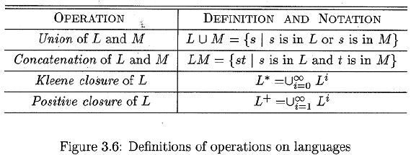

Compiler Design Notes
Regular Expressions:
Regular expressions have come into common use for describing all the
languages that can be built from these operators applied to the symbols of some
alphabet. In this notation, if letter_ is established to stand for any letter or the
underscore, and digit_ is established to stand for any digit, then we could describe the
language of C identifiers by:

letter_ (letter_ | digit)*

The vertical bar above means union, the parentheses is used to group subexpressions.
the star means "zero or more occurrences of," and the juxtaposition of letter_ with the
remainder of the expression signifies concatenation.

There are two rules that form the basis:

1. ε is a regular expression, and L (ε) is {ε) , that is, the language whose sole member is

the empty string.

2. If ‘a’ is a symbol in C, then a is a regular expression, and L(a) = {a).

There are four parts to the induction whereby larger regular expressions
are built from smaller ones. Suppose r and s is regular expressions denoting languages
L(r) and L(s), respectively.

1. (r)|(s) is a regular expression denoting the language L(r) U L(s).

2. (r) (s) is a regular expression denoting the language L(r) L(s) .

3. (r) * is a regular expression denoting (L(r)) * .

4. (r) is a regular expression denoting L(r).

regular expressions often contain unnecessary pairs of parentheses. We may drop
certain pairs of parentheses if we adopt the conventions that:

a) The unary operator * has highest precedence and is left associative.

b) Concatenation has second highest precedence and is left associative.

c) | has lowest precedence and is left associative.

Example 3.4: Let C = {a, b}.

1. The regular expression a1 b denotes the language {a, b}.

2. (a|b) (a|b) denotes {aa, ab, ba, bb), the language of all strings of length two over the

Prepared By Dipendra Air

21

Compiler Design Notes
alphabet C. Another regular expression for the same language is aa| ab | ba | bb.

3. a* denotes the language consisting of all strings of zero or more a's, that is, {ε, a, aa,
aaa, . . . }.

4. (a | b)* denotes the set of all of zero or more instances of a or b, that is, all strings of
a's and b's: {e, a, b, aa, ab, ba, bb, aaa, . . .}. Another regular expression for the same
language is (a*b*)*.

5. a|a*b denotes the language {a, b, ab, aab, aaab,. . .), that is, the string a and all strings
consisting of zero or more a's and ending in b.

The Algebraic laws for regular expressions are as follows.

Recognition of Tokens

How to express patterns using regular expressions?

Eg. A grammar for branching statements is as follows.

The terminals of the grammar, which are if, then, else, relop, id, and number & The
patterns for id and number is as follows.

Prepared By Dipendra Air
22
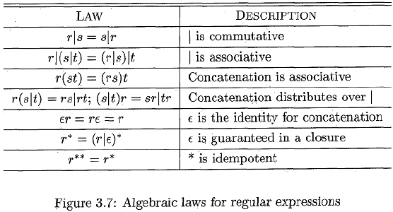

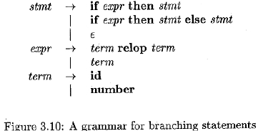

Compiler Design Notes

To simplify matters, we make the common assumption that keywords are also
reserved words: that is, they are not identifiers, even though their lexemes match the
pattern for identifiers.

Recognizing the "token" ws defined by:

ws
( blank | tab ( newline )+

Transition Diagrams

Transition diagrams have a collection of nodes or circles, called states. Each state
represents a condition that could occur during the process of scanning the input
looking for a lexeme that matches one of several patterns.
Edges are directed from one state of the transition diagram to another.
Each edge is labeled by a symbol or set of symbols.

Prepared By Dipendra Air
23
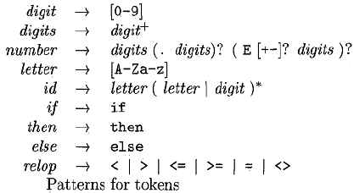

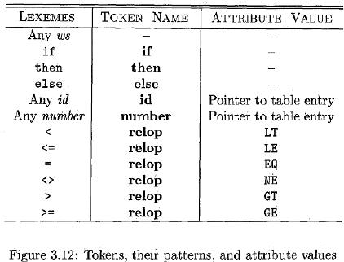

Compiler Design Notes
Some important conventions about transition diagrams are:

1.

Certain states are said to be accepting, or final. These states indicate that a lexeme

has been found, although the actual lexeme may not consist of all positions between
the lexemeBegin and forward pointers.
2. In addition, if it is necessary to retract the forward pointer one position (i.e., the
lexeme does not include the symbol that got us to the accepting state), then we shall
additionally place a * near that accepting state.
3. One state is designated the start state, or initial state;it is indicated by an edge,
labeled "start," entering from nowhere.
The transition diagram that recognizes the lexemes matching the token relop is as
follows.

Recognition of Reserved Words and Identifiers

Recognizing keywords and identifiers is as follows:

Prepared By Dipendra Air

24
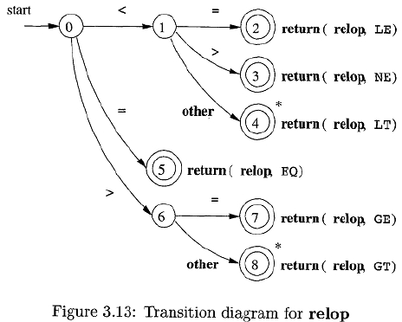

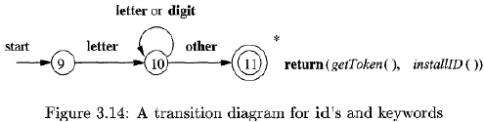

Compiler Design Notes
There are two ways that we can handle reserved words that look like identifiers:

1. Install the reserved words in the symbol table initially. A field of the symbol-table
entry indicates that these strings are never ordinary identifiers.
2. Create separate transition diagrams for each keyword;

Hypothetical transition diagram for the keyword then

The Lexical- Analyzer Generator Lex

Here a tool called Lex, or in a more recent implementation Flex, that allows one
to specify a lexical analyzer by specifying regular expressions to describe patterns for
tokens. The input notation for the Lex tool is referred to as the Lex language and the
tool itself is the Lex compiler.
The Lex compiler transforms the input patterns into a transition diagram and
generates code, in a file called lex.yy.c,

Use of Lex
Creating a lexical analyzer with Lex:

An input file, which we call lex.l, is written in the Lex language and describes the
lexical analyzer to be generated.
The Lex compiler transforms lex.l to a C program, in a file that is always named
lex.yy.c. The latter file is compiled by the C compiler into a file called a.out, as always.
The C compiler output is a working lexical analyzer that can take a stream of input
characters and produce a stream of tokens.

Prepared By Dipendra Air

25

Compiler Design Notes

Structure of Lex Programs

A Lex program has the following form:
declarations
%%
translation rules
%%
auxiliary functions

The declarations section includes declarations of variables, manifest constants
Each pattern is a regular expression, which may use the regular definitions of the
declaration section.
The third section holds whatever additional functions are used in the actions.
Lex program for the tokens is as follows.

Prepared By Dipendra Air

26
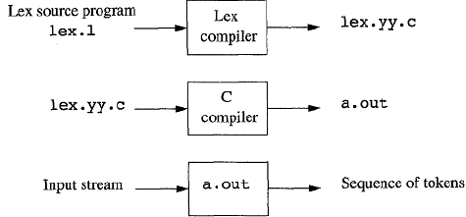

Compiler Design Notes
Design of a Lexical- Analyzer Generator

The Structure of the Generated Analyzer
The following figure gives overview of the architecture of a lexical analyzer generated
by Lex as follows.

These components are:
1. A transition table for the automaton.
2. Those functions that are passed directly through Lex to the output
3. The actions from the input program, which appear as fragments of code to be
invoked at the appropriate time by the automaton simulator.

The NFA constructed from a Lex program is as follows

Eg.
Consider the NFA’s for a, abb & a*b+ is as follows

Prepared By Dipendra Air

27
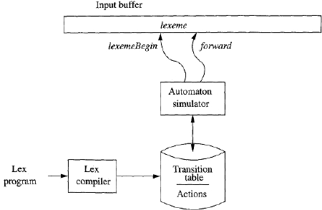

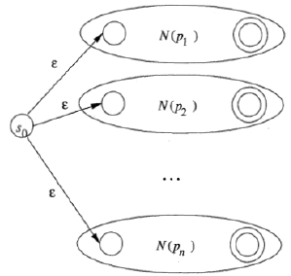

Compiler Design Notes

It can rearrange & the combined NFA is as follows.

If the lexical analyzer simulates NFA as is above figure, then it must read input
beginning at point on its input, which has referred to as lexemeBegin.
As it moves the pointer called read is forward ahead is the input. The sequence
of sets of states entered when processing input aaba as follows.

Prepared By Dipendra Air

28
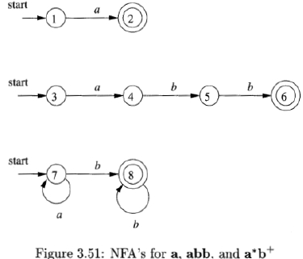

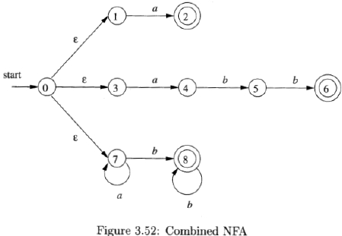

Compiler Design Notes

DFA’s for Lexical Analyzers:

Another architecture, resembling the output of Lex, is to convert the NFA for all
the patterns into an equivalent DFA, using the subset construction of Algorithm.

Transition graph for DFA handling the patterns a, abb, and a*b+

Implementing the Lookahead Operator:

The Lex lookahead operator / in a Lex pattern r1/r2 is sometimes necessary,
because the pattern rl for a particular token may need to describe some trailing
context r2 in order to correctly identify the actual lexeme.

The end occurs when the NFA enters a state s such that
1. s has an ε-transition on the (imaginary) /,
2. There is a path from the start state of the NFA to state s that spells out x.
3. There is a path from state s to the accepting state that spells out y.
4. x is as long as possible for any xy satisfying conditions 1-3.

Prepared By Dipendra Air

29
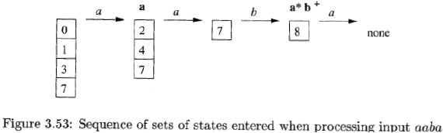

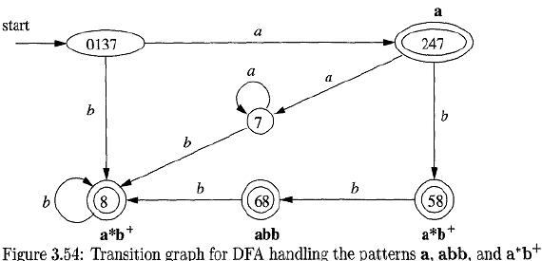

Compiler Design Notes
Finite Automata
Finite automata are recognizers; they simply say "yes" or "no" about each possible
input string.

Finite automata come in two flavors:

(a) Nondeterministic finite automata (NFA) have no restrictions on the labels of their
edges. A symbol can label several edges out of the same state, and ε, the empty
string, is a possible label.
(b) Deterministic finite automata (DFA) have, for each state, and for each symbol of
its input alphabet exactly one edge with that symbol leaving that state.

Nondeterministic Finite Automata:
A nondeterministic finite automaton (NFA) consists of:

1. A finite set of states S.
2. A set of input symbols C, the input alphabet. We assume that E, which stands for the
empty string, is never a member of C.
3. A transition function that gives, for each state, and for each symbol in C U (E) a set of
next states.
4. A state so from S that is distinguished as the start state (or initial state).
5. A set of states F, a subset of S that is distinguished as the accepting states (or final
states).

This NFA graph is very much like a transition diagram, except:
a) The same symbol can label edges from one state to several different states, and
b) An edge may be labeled by c, the empty string, instead of, or in addition to, symbols
from the input alphabet.

Prepared By Dipendra Air

30
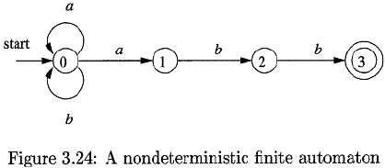

Compiler Design Notes
Deterministic Finite Automata:
A deterministic finite automaton (DFA) is a special case of an NFA where:
1. There are no moves on input ε, and
2. For each state s and input symbol a, there is exactly one edge out of s labeled a.

From Regular Expressions to Automata

Implementation of that software requires the simulation of a DFA. Because an
NFA often has a choice of move on an input symbol or on ε its simulation is less
straightforward than for a DFA. Thus often it is important to convert an NFA to a DFA
that accepts the same language.
The steps are

1. Construction of NFA from regular expression.
2. Conversion of NFA from DFA.

Construction of NFA from a regular expression:

McNaughton-Yamada-Thompson algorithm to convert a regular expression to an
NFA.
The algorithm is syntax-directed, in the sense that it works recursively up the parse
tree for the regular expression.
There are 2 rules for construction of NFA for subexpressions.

Basic rules for handling subexpressions with no operators:

Prepared By Dipendra Air

31
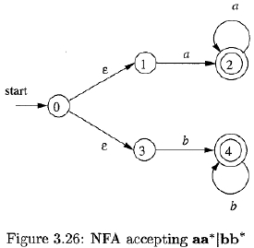

Compiler Design Notes
For expression ε constructs the NFA

For any subexpressiop a in Σ, construct the NFA as

Where, i is a new state
f is another new state

start state of this NFA,
accepting state for the NFA.

Induction Rules:

Used to construct larger NFA’s from the NFA’s for immediate subexpressions of given
expressions.

UNION:

Suppose r = s|t. Then N (r), the NFA for r, is constructed from N(s) &N(t). N(r) accepts L(S)U
L(t), which is same as L(r).

CONCATENATION:
Suppose r = st. The start state of N (s) becomes the start state of N (r), and the
accepting state of N(t) is the only accepting state of N(r). Thus, N(r) accepts exactly
L(s)L(t), and is a correct NFA for r = st.

Prepared By Dipendra Air

32
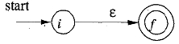

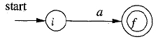

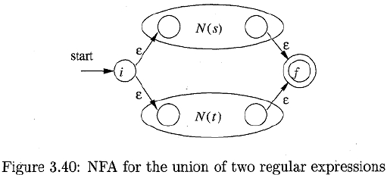

Compiler Design Notes

CLOSURE:

Suppose r = s*. Here, i and f are new states, the start state and lone accepting state of
N (r) . N(r) accepts ε, which takes care of the one string in L(s)0, & accepts all strings in

L(s)1, L(s)2 and so on

Finally, suppose r = (s). Then L(r) = L(s), and we can use the NFA N(s) as N(r).

The properties of N(r) are as follows:

1. N(r) has at most twice as many states as there are operators and operands in r.
2. N(r) has one start state and one accepting state.
3. Each state of N (r) other than the accepting state has either one outgoing transition

on a symbol in C or two outgoing transitions, both on ε.

Problem:

Construct an NFA for r = (a | b) * a b
The following figure shows parse tree for r.

Prepared By Dipendra Air

33

Compiler Design Notes

NFA for a (i.e) subexpression r1 N (r1)

NFA for b, Subexpression r2

N (r2)

NFA for a | b, (i.e) combine N (r1) & N(r2)

r3 = r1| r2

Prepared By Dipendra Air

34
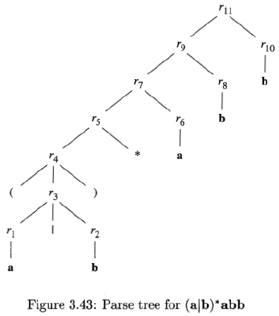

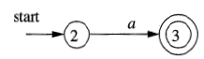

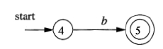

Compiler Design Notes

NFA for (a|b)*

i.e. for r4 = r3

r3=r1|r2

r5=(r3)*

NFA for r6: (i.e) a

NFA for r7=r5r6 (i.e) (a|b)*a

Prepared By Dipendra Air

35
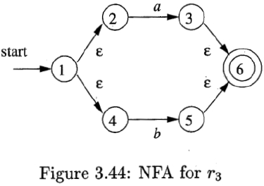

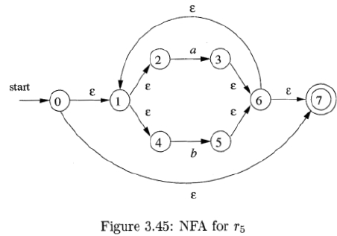

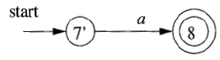

Compiler Design Notes

NFA for r8 (i.e)

NFA for (a|b)*abb:

Conversion fo NFA into DFA

The general idea behind the subset construction algorithm is that each state of the
constructed DFA corresponds to a set of NFA states.

Prepared By Dipendra Air

36
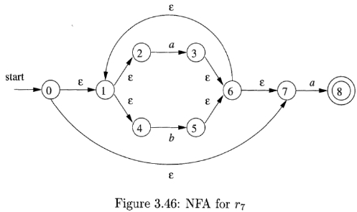

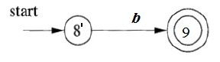

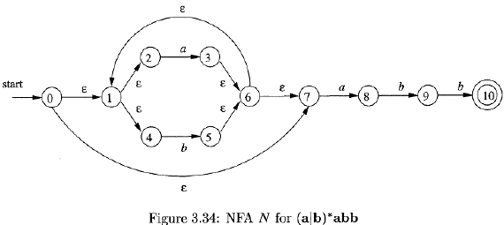

Compiler Design Notes

The construction of the set of D’s states, D states and transition function Dtran is shown
in the following subset construction algorithm.

initially, ε-closure(so) is the only state in Dstates, and it is unmarked;

while ( there is an unmarked state T in Dstates )
{
mark T;
for ( each input symbol a )
{

U = ε - closure(moue(T, a)) ;

if ( U is not in Dstates )
add U as an unmarked state to Dstates;
Dtran[T, a] = U;
}
}
Figure 3.32: The subset construction

The following algorithm showshow ε -closure(T) is computed for any set of

NFA states T using stack.

Prepared By Dipendra Air

37
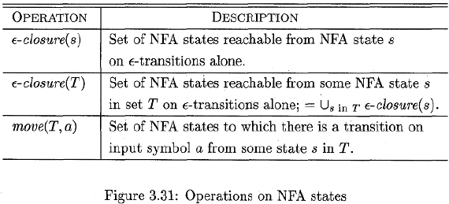

Compiler Design Notes

NFA for (a|b)*abb

ε – closure (0) = {0, 1, 2, 4, 7 } = A

Dtran[A, a] = ε – closure (move(A, a))
= ε – closure (3, 8)
= {1, 2, 3, 4, 6, 7, 8 }
=B

Dtran[A, b] = ε – closure (move(A, b))
= ε – closure (5)
= {1, 2, 4, 5, 6, 7 }
=C

Dtran[B, a] = ε – closure (move(B, a))
= ε – closure (3, 8)
= {1, 2, 3, 4, 6, 7, 8 }
=B

Prepared By Dipendra Air

38
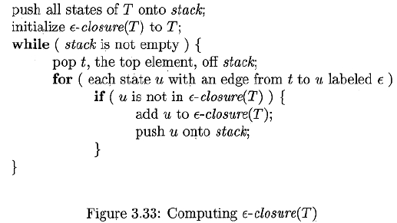

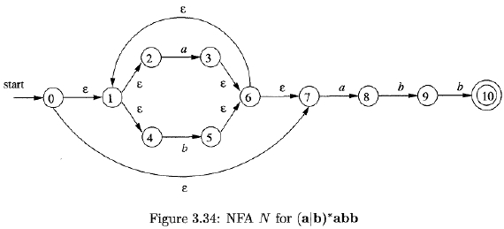

Compiler Design Notes
Dtran[B, b] = ε – closure (move(B, b))
= ε – closure (5, 9)
= {1, 2, 4, 5, 6, 7, 9 }
=D

Dtran[C, a] = ε – closure (move(C, a))
= ε – closure (3, 8)
= {1, 2, 3, 4, 6, 7, 8 }
=B

Dtran[C, b] = ε – closure (move(C, b))
= ε – closure (5)
= {1, 2, 4, 5, 6, 7 }
=C

Dtran[D, a] = ε – closure (move(D, a))
= ε – closure (3, 8)
= {1, 2, 3, 4, 6, 7, 8 }
=B

Dtran[D, b] = ε – closure (move(D, b))
= ε – closure (5, 10)
= {1, 2, 4, 6, 7, 10 }
=E

Dtran[E, a] = ε – closure (move(E, a))
= ε – closure (3, 8)
= {1, 2, 3, 4, 6, 7, 8 }
=B

Dtran[E, b] = ε – closure (move(E, b))
= ε – closure (5)
= {1, 2, 4, 5, 6, 7 }
=C

Fig. Transition table Dtran for DFA D

Prepared By Dipendra Air

39
NFA State | DFA State | a | b
{0, 1, 2, 4, 7 } | A | B | C
{1, 2, 3, 4, 6, 7, 8 } | B | B | D
{1, 2, 4, 5, 6, 7 } | C | B | C
{1, 2, 4, 5, 6, 7, 9 } | D | B | E
{1, 2, 4, 6, 7, 10 } | E | B | C

Compiler Design Notes

Optimization of DFA-Based Pattern Matchers

Important states of an NFA:

To begin our discussion of how to go directly from a regular expression to a DFA, we
must first dissect the NFA construction and consider the roles played by various states.

We call a state of an NFA important if it has a non- ε out-transition.

During the subset construction, two sets of NFA states can be identified if they:

1. Have the same important states, and
2. Either both have accepting states or neither does.

o

By concatenating a unique right endmarker # to a regular expression r, we give the

accepting state for r a transition on #, making it an important state of the NFA for
(r)#.
o By using the augmented regular expression (r)#, any state with a transition on #
must be an accepting state.
o to present the regular expression by its syntax tree, where the leaves correspond
to operands and the interior nodes correspond to operators.
An interior node is called
a cat-node is labeled by the concatenation operator (dot)
or-node is labeled by union operator |
star-node is labeled by star operator *

Prepared By Dipendra Air

40
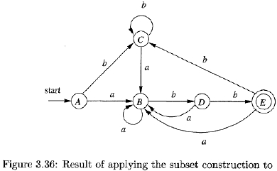

Compiler Design Notes

Leaves in a syntax tree are labeled by ε or by an alphabet symbol. To each leaf

not labeled ε, we attach a unique integer. We refer to this integer as the position of the

leaf and also as a position of its symbol.
The important states in NFA are numbered & other states represented by letters
as follows.

Functions Computed From the Syntax Tree:

To construct a DFA directly from a regular expression, we construct its syntax tree and
then compute four functions: nullable, firstpos, lastpos, and followpas.
Each definition refers to the syntax tree for a particular augmented regular expression
(r) # .

Prepared By Dipendra Air

41
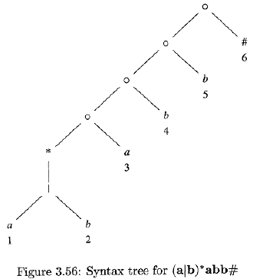

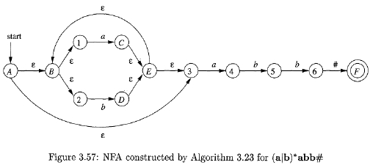

Compiler Design Notes
1. nullable(n) is true for a syntax-tree node n if and only if the subexpression

represented by n has ε in its language.

2. firstpos(n) is the set of positions in the subtree rooted at n that correspond to the
first symbol of at least one string in the language of the subexpression rooted at n.
3. lastpos(n) is the set of positions in the subtree rooted at n that correspond to the
last symbol of at least one string in the language of the subexpression rooted at n.
4. followpos(p), for a position p, is the set of positions q in the entire syntax tree such

that there is some string x = a1a2…. an, in L ((r)#) such that for some i, there is a

way to explain the membership of x in L((r)#) by matching ai to position p of the

syntax tree and ai+l to position q.

Example:

The expression (a|b)*a. We claim nullable(n) is false, since this node generates all

strings of a's and b's ending in an a; it does not generate ε.

firstpos(n) = {1,2,3)
lastpos(n) = (3)
followpos(1) = {1,2,3)

Computing nullable, firstpos, and lastpos:
The basis & induction rules for nullable(n), firstpos(n) lastpos(n) & followpos(n) is as
follows.

NODE n

A leaf labeled ε

A leaf with
position i

An or-node n = c1
|c2

A cat-node n = c1c2

A star-node n = c1*

nullable(n)

true

false

nullable(c1) or
nullable(c2)

nullable(c1)
and
nullable(c2)

True

firstpos(n)

Φ

{i}

firstpos(cl)U firstpos(c2)
if (nullable(c1))
firstpos(c1) U
firstpos(c2)
else
firstpos(cl)

firstpos(cl)

Lastpos(n)

Φ

{i}

lastpos(cl) U lastpos(c2)
if (nullable(c2))
lastpos(cl) U
lastpos(c2)
else
lastpos(c2)

Lastpos(c1)

Prepared By Dipendra Air

42
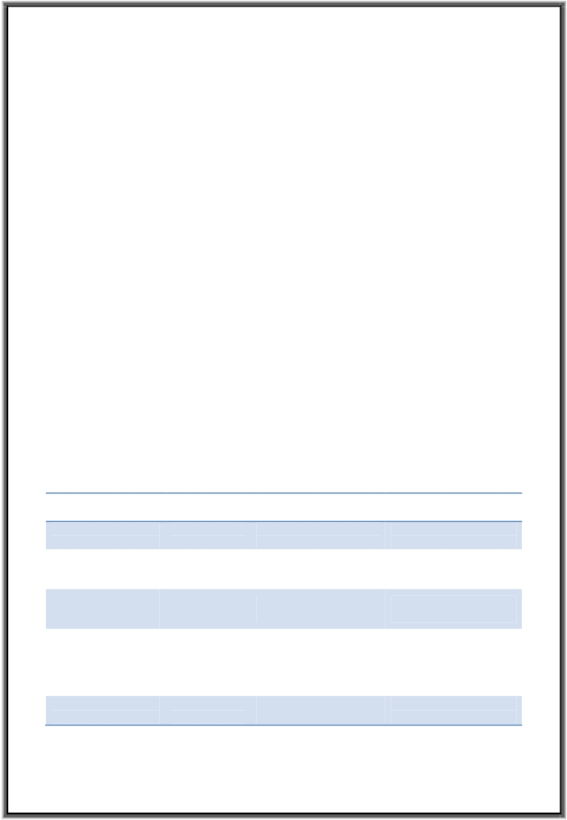

Compiler Design Notes

Computing followpos:

There are only two ways that a position of a regular expression can be made to
follow another.
1. If n is a cat-node with left child C1 and right child C2, then for every position i in
lastpos(c1), all positions in firstpos(c2) are in followpos(i).
2. If n is a star-node, and i is a position in lastpos(n), then all positions in firstpos(n)
are in followpos(i) .

The directed graph for followpos is as follows.

Prepared By Dipendra Air

43
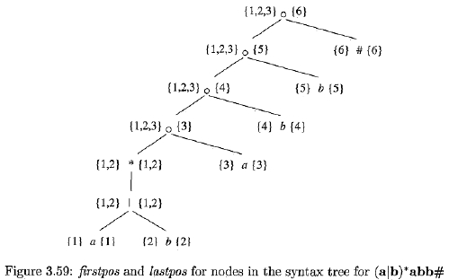

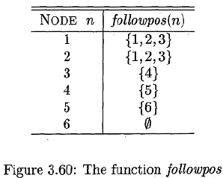

Compiler Design Notes

The followpos is almost an NFA without ε-transitions for the underlying regular

expression, and would become one if we:

1. Make all positions in firstpos of the root be initial states,
2. Label each arc from i to j by the symbol at position i, and
3. Make the position associated with endmarker # be the only accepting state.

The Role of the Parser:

In our compiler model, the parser obtains a string of tokens from the
lexical analyzer and verifies that the string of token names can be generated by
the grammar for the source language.
We expect the parser to report any syntax errors in an intelligible fashion and to
recover from commonly occurring errors to continue processing the remainder of the
program. Conceptually, for well-formed programs, the parser constructs a parse tree
and passes it to the rest of the compiler for further processing. In fact, the parse tree
need not be constructed explicitly, since checking and translation actions can be
interspersed with parsing. Thus, the parser and the rest of the front end could well be
implemented by a single module.
There are three general types of parsers for grammars:

•

•

•

universal

top-down
bottom-up

Prepared By Dipendra Air

44
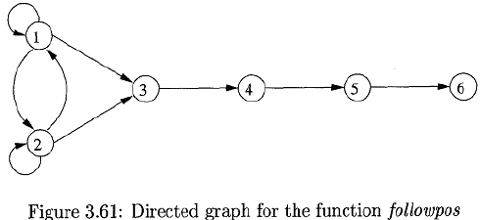

Compiler Design Notes

Universal parsing methods such as the Cocke-Younger-Kasami algorithm and
Earley's algorithm can parse any grammar. It’s too inefficient to use in production
compilers.
Top-down methods build parse trees from the top (root) to the bottom (leaves),
while bottom-up methods start from the leaves and work their way up to the root.
In either case, the input to the parser is scanned from left to right, one symbol at a time.

Representative Grammars:

Constructs that begin with keywords like while or int, are relatively easy to parse.
It concentrate on expressions, which present more of challenge, because of the
associativity and precedence of operators.

Consider the grammer as follows.

E
T
F
E+T|T
T*F|F
(E) | id

Where E represents expressions, T represents terms, F represents factors.
Above grammar is suitable for bottom up parsing & it cant be used for top-down
parsing because it is left recursive.

The non-leaf recursive grammar is as follows.

E

E'

T
T'
F

T E'
+ T E'| ε
F T'
* F T’ | ε
(E) | id

Prepared By Dipendra Air
45
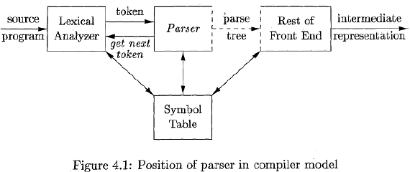

Compiler Design Notes
Syntax Error handling:

Common programming errors can occur at many different levels.

Lexical errors
Include misspellings of identifiers, keywords, or operators - e.g., the use of an
identifier elipsesize instead of ellipsesize - and missing quotes around text intended
as a string.

Syntactic errors
Include misplaced semicolons or extra or missing braces; that is, “{"or "}.". As
another example, in C, the appearance of a case statement without an enclosing
switch is a syntactic error.

Semantic errors
Include type mismatches between operators and operands. An example is a
return statement in a Java method with result type void.

Logical errors
can be anything from incorrect reasoning on the part of the programmer to
the use in a C program of the assignment operator = instead of the comparison
operator ==.

Parsing methods allows syntactic errors to be detected very efficiently. It has
the viable-prefix property, meaning that they detect that an error has occurred as soon
as they see a prefix of the input that cannot be completed to form a string.
A few semantic errors, such as type mismatches, can also be detected efficiently;
however, accurate detection of semantic and logical errors at compile time is in general
a difficult task.
The goals of error handler are as follows.

•

•

•

Report the presence of errors clearly and accurately.

Recover from each error quickly enough to detect subsequent errors.
Add minimal overhead to the processing of correct programs.

Error-Recovery Strategies:

Once an error is detected, how should the parser recover? Although no strategy

Prepared By Dipendra Air

46

Compiler Design Notes
has proven itself universally acceptable, a few methods have broad applicability. The
simplest approach is for the parser to quit with an informative error message when
it detects the first error.
If errors pile up, it is better for the compiler to give up after exceeding some
error limit than to produce an annoying avalanche of "spurious" errors.

Panic-Mode Recovery:

With this method, on discovering an error, the parser discards input symbols one at a
time until one of a designated set of synchronizing tokens is found. The synchronizing
tokens are usually delimiters, such as semicolon or },

Advan:

-
-
Simplicity
Not leads to infinite loop.

Disadvan:

-
It often skips a considerable amount of input without checking it for additional

errors.

Phrase-Level Recovery:

On discovering an error, a parser may perform local correction on the remaining input;
i.e it may replace a prefix of the remaining input by some string that allows the parser
to continue.
A typical local correction is to replace a comma by a semicolon, delete an extraneous
semicolon, or insert a missing semicolon.

Advan:

-

Phrase-level replacement has been used in several error-repairing compilers, as

it can correct any input string.

Disadvan:

-

-

we must be careful to choose replacements that do not lead to infinite loops,as
it can correct any input string.
Its major drawback is the difficulty it has in coping with situations in which the
actual error has occurred before the point of detection.

Prepared By Dipendra Air

47

Compiler Design Notes
Error Productions:

By anticipating common errors that might be encountered, we can augment the
grammar for the language at hand with productions that generate the erroneous

constructs.
A parser constructed from a grammar augmented by these error

productions detects the anticipated errors when an error production is used
during parsing. The parser can then generate appropriate error diagnostics about the
erroneous construct that has been recognized in the input.

Global Correction

-

-

Here, algorithms are used for choosing a minimal sequence of changes to obtain
a globally least-cost correction.
For a given an incorrect input string x and grammar G, these algorithms will

find a parse tree for a related string y, such that the number of insertions,
deletions, and changes of tokens.
Disadvan:

-

Too costly to implement in terms of time & space.

A Simple Syntax-Directed Translator

Syntax Definition - Context-free grammar

-

-
The "context-free grammar” or "grammar" for short- that is used to specify the
syntax of a language.
A grammar naturally describes the hierarchical structure of most programming

language constructs. For example, an if-else statement in Java can have the form

if ( expression ) statement else statement

Using the variable expr to denote an expression and the variable stmt to denote a
statement, this structuring rule can be expressed as

stmt
if ( expr ) stmt else stmt

in which the arrow may be read as "can have the form." Such a rule is called a
production. In a production, lexical elements like the keyword if and the parentheses
are called terminals. Variables like expr and stmt represent sequences of terminals
and are called nonterminals.

Prepared By Dipendra Air

48

Compiler Design Notes
Definition of Grammars

A context-free grammar has four components:

1. A set of terminal symbols, sometimes referred to as "tokens." The terminals are the
elementary symbols of the language defined by the grammar.
2. A set of nonterminals, sometimes called "syntactic variables." Each nonterminal
represents a set of strings of terminals, in a manner we shall describe.
3. A set of productions, where each production consists of a nonterminal, called the
head or left side of the production, an arrow, and a sequence of terminals and/or
nonterminals, called the body or right side of the production. The intuitive intent of a
production is to specify one of the written forms of a construct; if the head
nonterminal represents a construct, then the body represents a written form of the
construct.
4. A designation of one of the nonterminals as the start symbol.

The grammar describes the syntax of the expressions as "lists of digits separated by
plus or minus signs":

list
list
list
digit

list
list + digit
list - digit
digit
0|1|2|3|4|5|6|7|8|9

list + digit | list - digit | digit

Derivations

A grammar derives strings by beginning with the start symbol and repeatedly
replacing a nonterminal by the body of a production for that nonterminal. The terminal
strings that can be derived from the start symbol form the language defined by the
grammar.
Parsing is the problem of taking a string of terminals and figuring out how to
derive it from the start symbol of the grammar, and if it cannot be derived from the
start symbol of the grammar, then reporting syntax errors within the string.

Prepared By Dipendra Air

49

Compiler Design Notes
Parse Trees
A parse tree pictorially shows how the start symbol of a grammar derives a

string in the language. If nonterminal ‘A’ has a production A
XYZ, then a parse tree

may have an interior node labeled A with three children labeled X, Y, and Z, from left
to right:

Formally, given a context-free grammar, a parse tree according to the grammar is a tree
with the following properties:
1. The root is labeled by the start symbol.

2. Each leaf is labeled by a terminal or by ε.

3. Each interior node is labeled by a nonterminal.
4. If A is the nonterminal labeling some interior node and XI, Xz, . . . , Xn are the labels of
the children of that node from left to right, then there must be a production

A

X1, X2 . . Xn.

Example:
Parse tree for 9-5+2 according to the grammar

list
list + digit | list - digit | digit & digit
0 | 1 | 2 | 3 | 4 | 5 | 6 | 7 | 8 | 9 as follows:

Ambiguity:

A grammar can have more than one parse tree generating a given string of terminals.
Such a grammar is said to be ambiguous.

Eg. Grammar

string

string + string | string – string | 0 | 1 | 2 | 3 | 4 | 5 | 6 | 7 | 8 | 9

Prepared By Dipendra Air

50
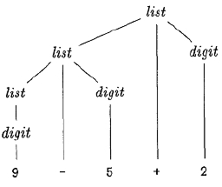



Compiler Design Notes

Associativity of Operators

In programming languages the four arithmetic operators, addition, subtraction,
multiplication, and division are left-associative. Some common operators such as
exponentiation are right-associative.

The expression a=b=c is equivalent to a= (b=c).

Precedence of Operators:

•

•

Precedence Rules defining the relative precedence of operators are needed when
more than one kind of operator is present.
* has higher precedence than + if * takes its operands before + does.

• the expressions are equivalent to 9+ (5*2) and (9*5) +2, respectively.

Postfix Notation

This section deals with translation into postfix notation. The postfix notation for an
expression ε can be defined inductively as follows:

1. If E is a variable or constant, then the postfix notation for E is E itself.
2. If E is an expression of the form El op E2, where op is any binary operator, then the
postfix notation for E is E1’ E2’ op, where E1’ and E2’ are the postfix notations for E1
and E2, respectively.
3. If E is a parenthesized expression of the form (E1), then the postfix notation for E is
the same as the postfix notation for E1.

Prepared By Dipendra Air

51
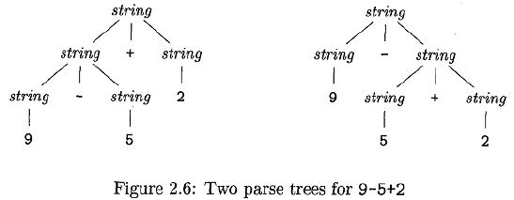

Compiler Design Notes

The postfix notation for ( 9 – 5 ) + 2 is 9 5 – 2 +.
The postfix notation for 9 - ( 5 + 2 ) is 9 5 2 + -.

Tree Traversals

A traversal of a tree starts at the root and visits each node of the tree in some order.
Tree traversals will be used for describing attribute evaluation and for specifying
the execution of code fragments in a translation scheme.
A depth-first traversal starts at the root and recursively visits the children of each
node in any order, not necessarily from left to right.
It is called "depth first" because it visits an unvisited child of a node whenever it
can, so it visits nodes as far away from the root (as "deep") as quickly as it can.
The procedure visit (N) is a depth first traversal that visits the children of a node in
left-to-right order.

Prepared By Dipendra Air

52
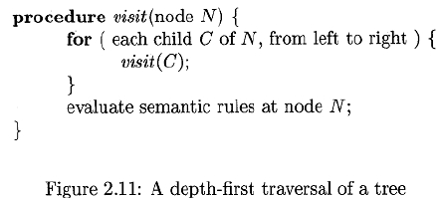

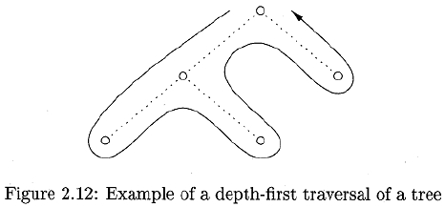

Compiler Design Notes

Synthesized attributes can be evaluated during any bottom-up traversal, that is,
a traversal that evaluates attributes at a node after having evaluated attributes at its
children.

Parsing

Parsing is the process of determining how a string of terminals can be generated by a
grammar.
Most parsing methods fall into one of two classes, called the top-down and bottom-up
methods.
Top-down parsers, construction starts at the root and proceeds towards the
leaves,
Bottom-up parsers, construction starts at the leaves and proceeds towards the
root.

